Experment-4

Car Booking Reservation System

Aim :- To develop and deploy a simple Car Booking Reservation System as a Software-as-a-Service (SaaS) application using a Cloud Service Provider for online car rental and reservation management.

PROCEDURE :-
- Select a cloud service provider such as AWS / Microsoft Azure / Google Cloud.
- Create a cloud account and set up hosting or virtual server services.
- Design system modules including user registration, car listing, booking, and payment.
- Develop the frontend using HTML/CSS/JavaScript.
- Implement backend functionality using PHP / Python / Node.js.
- Configure a cloud database to store car details, users, and booking records.
- Deploy the application on the cloud and test it via web browser access.
OUTPUT :-

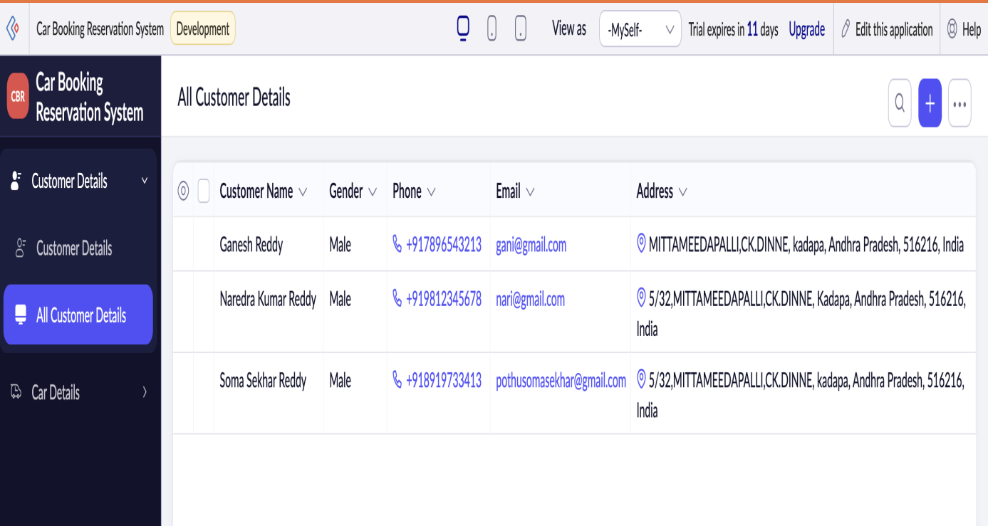

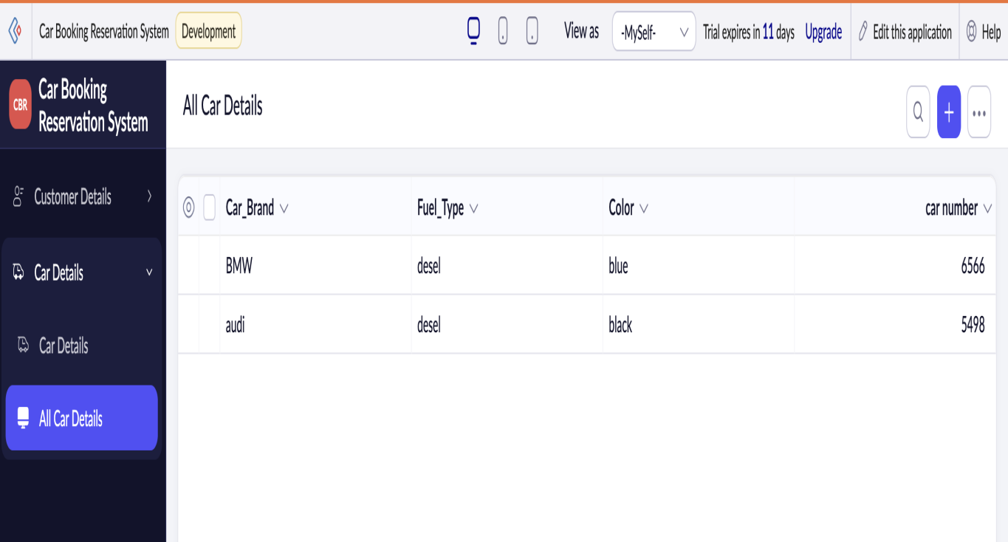

RESULT :-
The Car Booking Reservation System was successfully deployed on the cloud platform.It demonstrated SaaS capabilities such as online reservations, centralized management, and scalable access.

